**Reaching the Chokosi People of Ghana**

**by Kerry A. Olson**

*As our vehicle approached the village school facilities in northeastern Ghana, an amazing scene unfolded before our eyes. Hundreds of colorfully dressed Chokosi people were already congregating for the first-ever “celebration gathering” marking the emergence of the Chokosi (Anufo) church in that region. How was it possible that only three months previous the first Ghanaian missionary had been sent to this tribal territory?*

**A Remarkable Emerging Movement**

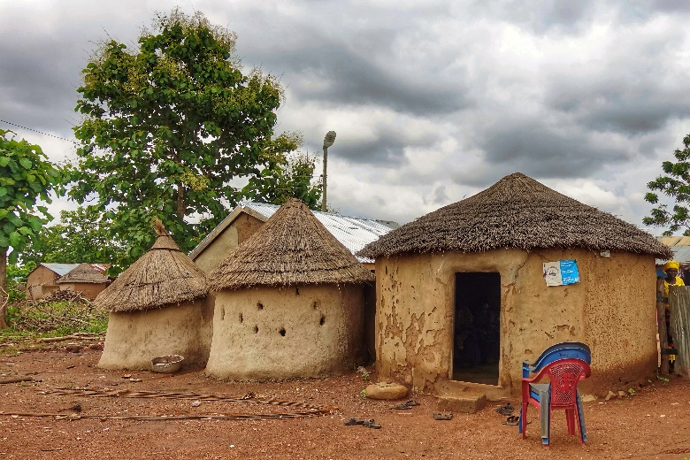Over the past several years, I’ve traveled extensively with my Ghanaian ministry colleague and friend, Sam Dunya, to document the remarkable work of God as he and his ministry team tirelessly plant churches among unreached people groups in northern Ghana, a region predominantly inhabited by Muslims. This time, as we journeyed from the northern city of Tamale into the increasingly arid landscape of northeastern Ghana, Sam smiled and said, “We are all in for a real blessing today!”

**The Tribal "Palace" (Office of a Chokosi village chief)**

Prior to our arrival at the venue for the first major assembly of these new Chokosi believers and seekers, which they termed a “Celebration Service,” Sam briefed us on the inspiring development. Just three months before our visit, Emmanuel, a recent graduate from his missionary training school, had been sent to the Chokosi tribal territory. Remarkably, in this short span, God used Emmanuel to initiate twelve Discovery Bible studies across six Chokosi villages.

As our vehicle entered the village, it was hard to imagine that hundreds of Chokosi were already gathered together for the event. Adhering to tribal customs, our first order of business was to pay our respects at the nearby “palace” of the tribal chief and elders. Here, we were graciously received and granted permission to conduct the planned celebration within their territory.

The event began with Chokosi women and young girls gracefully performing their traditional dances. In the open air, impromptu messages were delivered, urging the Chokosi to embrace the path of “followers of Jesus” and to persevere in their weekly Discovery Bible studies, diligently applying the teachings of God’s Word to their lives. Missionary Emmanuel invited several new Chokosi believers to share their testimonies, which left a profound impact on the people who had assembled. Almost every testimony echoed a similar sentiment: “I’ve only recently begun attending a Discovery Bible study. At first I thought I was among the few Chokosi who followed Jesus. However, upon arriving at this celebration gathering, I am astounded to discover so many fellow believers.”

**Chokosi men and women dancing at the first-ever Church Celebration Gathering**

**The Chokosi People**

The Chokosi people in Ghana number about 122,000. Their origins trace back to the mid-1700s when a significant contingent of mercenaries departed from the neighboring country of Côte d’Ivoire (also known as Ivory Coast) to aid two dominant conquering tribes in Ghana. Over time, they integrated into the villages they once pillaged. Their language, Anufo, is a fusion of their original tongue and Twi, spoken in approximately two-thirds of Ghana. Presently, the Chokosi inhabit the savannah grassland bordering the country of Togo, where nearly 100,000 Chokosi reside, with over 1 percent having embraced Christianity—a notable contrast to the historically sparce Christian presence in Ghana.

The Chokosi dwell in an area of Ghana dominated by two larger tribes, the Mamprusi and the Konkomba. Historically, the Chokosi and Konkomba have been rivals. As a young boy, the missionary Emmanuel, himself a Konkomba, could scarcely have envisioned that God would call him to minister to the Chokosi.

**Back to Basics**

**Chokosi Teenager**

Since his arrival three years ago, Emmanuel has born witness to the exponential growth of God’s work among the Chokosi community, a testament to his steadfast faithfulness and the application of some basic movement principles, such as Discovery Bible studies, finding a person of peace, and obedience-based discipleship.

*Discovery Bible study* (DBS) is a simple, yet profoundly impactful discipleship process centered on opening the Bible with someone who doesn’t yet show they are following Jesus, encouraging them to put His teachings into practice. This allows participants to discover God’s truth for themselves rather than relying on a leader.

*Finding a person of peace* is a biblical concept and entry strategy into new communities, where a local person is key to bridging the gospel to their relational network (family, friends, community, workplace, etc.).

*Obedience based discipleship*stresses the importance of teaching people to obey the Bible rather than simply teaching people Bible content.

**Exponential Growth**

The labor of Emmanuel and his wife, Cristiana, has born fruit, with 90 vibrant Discovery Bible studies flourishing across 15 villages with an average of 6–7 believers or seekers in attendance for a total of well over 500 participants. Moreover, all of the 15 village study groups convene monthly as a Celebration Church, providing communal space for worship, fellowship, and ongoing spiritual growth. Here individuals are continually challenged to deepen their commitment to Christ and extend invitations to others to join them on their journey of discipleship.

In a recent testament to the life-changing power of God’s Word, an incident unfolded in a Chokosi village where the seeds of the church were taking root. A disgruntled villager voiced his objections to the local chief, citing the presence of Christian Bible studies near his residence. He asserted, “We Chokosi are Muslim!” Surprisingly, the chief’s response defied expectations. He expressed no opposition, revealing that he himself was actively participating in one of the Discovery Bible studies—a powerful testament to the inclusive and transformative nature of God’s Word.

**Pray**

* for the establishment and flourishing of a robust indigenous Chokosi church in northeastern Ghana, that it may stand as a beacon of God’s love and truth in the region
* for the transformation of the current seekers among the Chokosi community into committed believers who will be empowered to raise up the next generation of disciple makers
* for the extension of the Chokosi church beyond its current boundaries, penetrating numerous other villages as well as other ethnic groups where the light of Christ has yet to shine brightly.
* specifically for Emmanuel, Cristiana, and their daughter, that they would continue to serve as catalysts for spiritual growth in the region.
* for the expansion of the work to encompass the unreached tribes of Ghana and West Africa, beseeching the Lord of the harvest to send out more workers into His harvest field.