Missionary Training Resource Team Report

# Move 100 Goal

Throughout the GlobeServe partnership there are currently 500 UPG engagements that are active, with that number likely to rise. Our desire is to see all UPGs continue to move through the seven stages of engagement to see disciple-making movements present among all of them, with a current goal of seeing 100 of these engagements hit the movement stage by the year 2033.

# Purpose

While the fulfillment of this goal relies heavily on the move of the Spirit among these people groups, it also requires great intentionality on the part of the members in the way they engage the UPGs.

The purpose of the *GlobeServe Missionary Training Resource Team* is to facilitate the development of training initiatives which are focused on training missionaries to see disciple-making movements established among unreached people groups, and to facilitate excellence and collaboration among GlobeServe members involved in training.

# Functions

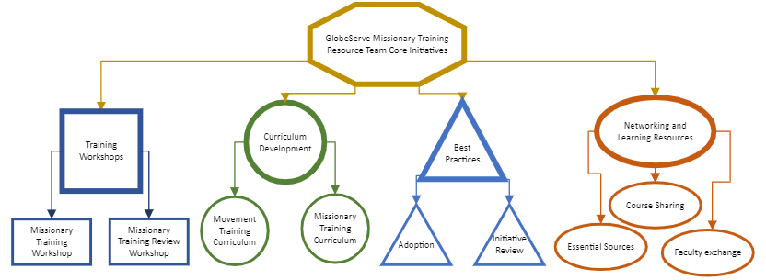There are four key initiatives of the GlobeServe Missionary Training Resource Team are shown in the chart below and explained as follows:

#### Training Workshops.

To develop and conduct training workshops and consultations that serve to build training initiatives within GlobeServe which work toward the establishment of church planting movements among unreached people groups.

This category has room for expansion. Currently the only active initiative here is the Missionary Training Workshop.

* Missionary Training Workshop – This staple Workshop of GlobeServe has been redeployed in a new format and is being evaluated with improvements to be made across Central and West Africa. There is an opportunity now to bring this training beyond to the entire GlobeServe body as needed.
* Missionary Training Review Workshop – This is still in concept form, but there is a great likelihood that some Hubs within GlobeServe might benefit from a review workshop to re-engage/kickstart missionary training. Other existing schools might benefit from a refresher on the components.
* A test project is being developed to place the MTW workshop into an online course format for use after the live seminar.

#### Curriculum Development

To develop relevant and highly contextualizable curricula for use and modification as needed by GlobeServe partner training initiatives.

Building off past successes and some of the work of John Kayser and others, GlobeServe is positioned to begin a strong global sharing of curriculum resources.

This category also has room for expansion.

* Missionary Training Curriculum – This started with a Bethany International initiative to develop packaged courses on key subjects of missionary training which could be used by GlobeServe partners. This can be expanded greatly with contributions of successful courses from GlobeServe partners. To be useable, courses must be designed in such a way as to be contextually adjustable as needed by the partner using them.
* Movement Training Curriculum – We have wondered as a team if there would be a separate stream of movement-oriented curriculum to train missionary school leaders and faculty to think and teach more from a movement perspective. This has not yet been developed.

#### Implementation of Standards of Best Practices

To broadly disseminate and encourage the adoption and implementation of the GlobeServe Standards of Best Practices in Missionary Training.

The GlobeServe Standards of Best Practices were developed and approved by the GlobeServe council early in 2023. Now broad dissemination is needed with two main objectives:

* Adoption. With hundreds of large and small training initiatives engaged in GlobeServe, raising awareness of the Standards, and encouraging adoption of and alignment with the Standards is now a strong need.
* Initiative Review – The Standards are designed with the idea that they would become a basis for a process of peer review between training initiatives. As the GTI team grows there will be opportunities to train regional representatives to begin scheduling and prototyping this process.

#### Networking and Learning Resources

To promote collaboration in the sharing of learning resources between GlobeServe partner training initiatives.

In alignment with the idea of Curriculum Development, we believe that a growing GlobeServe has an opportunity for a higher level of sharing of learning resources between members around the world. This would include:

* Sharing of course outlines, materials, syllabi, and concepts – Existing GlobeServe partner schools have done a lot of the work of designing excellent missionary training for their own context. Newer partner schools can benefit from this expertise if GlobeServe can develop a platform for sharing and dissemination where materials and ideas can be made available to schools throughout the GS family for use and modification within their own context.
* Faculty Exchange – Many GlobeServe schools have benefited greatly from visiting faculty, especially in the early days of a school when there is no one available in the context to teach certain topics. Especially regionally, we could encourage stronger schools to allow some of their teachers to teach in other GlobeServe schools. Hubs would need to work out the management of the costs involved.
* Essential Sources – this is a concept still. The idea would be to take core resources on missions, movements, ecclesiology, anthropology, etc. and write Easy English concept papers on these topics, citing the core resources. This would result in a non-copyrighted (or our own copyright) document which could be placed in a compendium/reader for various courses. This would be a lot of work, but we could commission it from various missionaries, teachers, and leaders, or even graduate level students.

# Team Structure and Membership

In keeping with the scope described by the Structure Working Group, we propose that the name of this new team be the “GlobeServe Training Resources Initiatives (GTRI) Team”.

This GTRI team would be made up of a few legacy members of the GTC (see Historical Background below) but expanded to a wider representation of GlobeServe members over time. This representation should be drawn from within GlobeServe regions and include people with knowledge, skills, and experience in training.

#### Current membership

The recommended initial team was:

* Paul Hartford
* Segun Adekoya
* Sunday Ajibade

New representatives from Francophone Africa already identified as:

* Kassum Balbone – West Francophone Africa
* Lazare Naida – Central Francophone Africa

New representatives should now be identified from

* Southeast Asia
* South Asia
* Indonesia
* East Africa

With the team growth, the team would eventually choose a core team to lead the wider team.

#### Team member qualifications

* A member in good standing of a GlobeServe Hub
* Significant intercultural ministry experience
* Significant experience as a trainer
* Significant training as a trainer
* Committed to GlobeServe principles, practices, and goals
* Ability to travel
* Willingness of organization to release time for travel

# Connections within GlobeServe

The Missionary Training Resource Team must collaborate and/or coordinate with the following GlobeServe groups:

* GlobeServe Council (through the Team Coordinator)
* International Coordinating Team
* Regional Coordinators
* Partnership Development and Networking Resource Team
* Movement Resource Team
* Research & Information Team

# Current Resources

The current resources at the disposal of the GlobeServe Missionary Training Resource Team include, but are not limited to:

* The Missionary Training Workshop
  + Workshop Handbook in English and French
  + Workshop Seminar Outlines and Presentations in English and French
  + Workshop trainers and coaches
* The Missionary Curriculum Project
  + 2 fully developed and 3 partially developed sharable course outlines and materials
  + A large collection of course outlines and materials from the work of Bethany International and partners in Asia.
* The GlobeServe Standards of Best Practice in Missionary Training